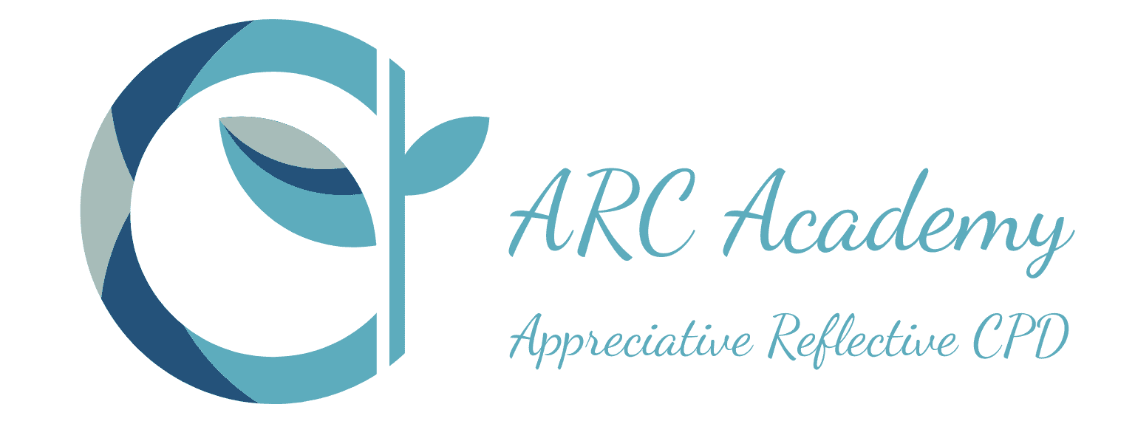

ARC Supervision Skills Portfolio
Avoiding Burn-Out: Supportive Supervision
This Study Day is part of ARC Supervision’s extended supervision skills portfolio. During the course a range of strategies for supporting others are explored. This course is relevant to both clinical/professional and management supervision.

The focus is on recognising the signs of burnout and exploring strategies which help towards restoring motivation.

Sometimes supervision is supportive or restorative. The two terms are interchangeable. We bring the ‘issues’ to supervision which have been unsettling or unusual and explore our response and how we might do things differently in a similar situation in the future. This is offloading the mental grime which builds up during our professional work.

There are times when we notice that someone is approaching burnout, with loss of motivation and stressed outlook. Burnout can also be called chronic emotional stress. This is where more specific supervisory support is valuable in restoring resilience and job satisfaction. This is the time for strategies supporting resilience.

There are 3 functions of Clinical Supervision. These were identified by Brigid Procter and have stood the test of time. These are developmental/educative, normative/operational and supportive/restorative supervision. This course focuses on restorative/supportive supervision which links with avoiding burnout and facilitating wellbeing at work.


“the aim of those providing restorative clinical supervision is to help staff build their own resilience to diminish their stress and burnout; emphasis is placed on improving their wellbeing, which will support their ability to make appropriate clinical decisions in complex situations.” Rouse (2019)

Participants are introduced to the research of Sonya Wallbank and the Restorative Resilience model of supervision because of its relevance in SLT. The suggested strategies to reduce stress and avoid burnout are explored e.g. stress inoculation.

Those working in caring professions are known to be more at risk of burnout or living/working while in a state of approaching burnout. The signs of burnout and how to tailor strategies to different levels of chronic emotional stress are explored.

The opposites of chronic emotional stress at work and what makes us more likely to be happy and motivated at work is also covered. The work of Penn State on Positive Psychology and Pennebaker on Expressive Writing will be used for this. How we can thrive at work rather than just surviving.

The Course Tutor has a published book with Speechmark/Routledge “Reflective Clinical Supervision in SLT: Strengthening your Supervision Skills” and the content links closely with the content of this book.

Who is this course for?
This course is relevant across healthcare and educational professions.

- Speech & Language Therapists
- Other AHPs - OTs, Physios
- Education colleagues
- Those who support others – managers and supervisors
- Those who want to know more about ‘how to’ practically support colleagues who feel overwhelmed and struggling at work e.g. in peer supervision

This course explores Restorative/Supportive supervision. The insight gained into ‘how to support people who are approaching burnout’ will be valuable to anyone supporting others in the workplace. The course leader has found this framework useful in both clinical supervision and managerial support.

What does it cover?
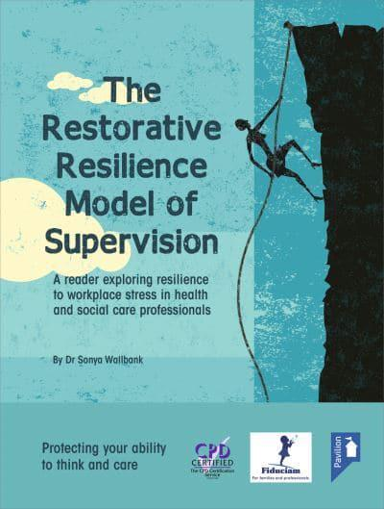

- the 3 functions of supervision (Procter)
- restorative supervision
- resilience at work
- the emotional load we carry at work
- burnout & change of attitudes to work
- building & maintaining resilience
- coping strategies for processing stressful events at work
- The restorative resilience model of supervision
  - Background/research
  - Signs of approaching burnout
  - Negative and positive zones of performance
  - Moving out of dismal negativity
  - Matching strategies to zones – emotional containment, active listening, reflective practice, coaching
  - Stress Inoculation – Assertiveness & Resilience strategies
  - Group Supervision – for ongoing support
- Wider strategies for Wellbeing at work
- What makes a good week at work more likely?
- Positive Therapy at work – visiting some strategies
- Expressive Writing as a wellbeing tool
What will I achieve? (Learning outcomes and objectives)

By the end of this course you will:
- know about how restorative function of supervision fits into a wider model of supervision
- have wider knowledge of resilience and what supports it
- have insight into what makes wellbeing at work more likely
- feel confident about supervising in a restorative resilience approach
- have explored burnout and know about positive and negative zones
- recognize burnout and signs that a colleague is approaching burnout
- know specific techniques to utilise to support others in supervision
- know the limits of supervision in supporting individuals
- know about stress inoculation and fostering assertiveness
- be able to discuss restorative supervision and its components confidently with others
- know the part that ongoing supervision (individual or group) can play in supporting resilience in the workplace
- Know what makes a Good Day at Work more likely
- Be able to use some positive therapy strategies
- Know about the research/technique of expressive writing.

In summary, this course gives participants a comprehensive insight into the theoretical principles and evidence supporting a restorative approach to supervision. You will reflect on your own situation and how to put strategies into action and using the techniques in daily practice.
How will I be taught, will there be any work outside the class?
- The Program is online via Teams.
- The Course Tutor is Ruth (Howes).
- There are presentations of theory and information, which always include time to share and discuss ideas.

Cost
£150
When and how long
See Course calendar for latest dates
Full day 9.30 to 4.00
Booking
- You can book and pay instantly via PayPal
- You can ask for a quotation so your organisation can raise a purchase order
- You can ask us to send an invoice to yourself or your employer that can be paid by BACS
- Card Payment through Stripe will be available soon

