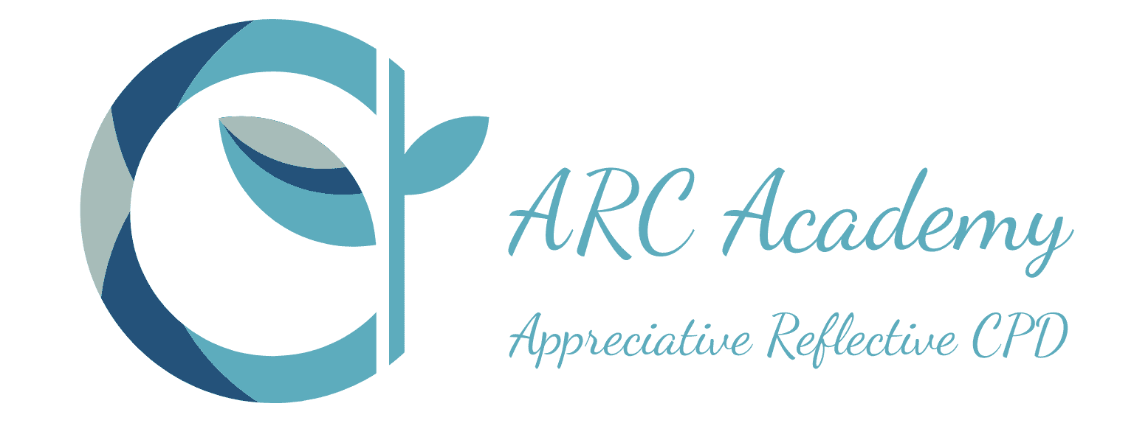

Clinical Supervision; Strengthening your Toolkit
The course focuses on Clinical (aka Professional Supervision) Supervision. The Course Lead has a forthcoming book with Speechmark, Routledge “Reflective Clinical Supervision in SLT: Strengthening your Supervision Skills’ and the content links closely with the content of this book.
Who is this course for?
- Speech & Language Therapists
- Assistant Practitioners in Speech & Language Therapy
- Other AHPs - OTs, Physios
- AHP Assistants e.g. OT and Physio

What does it cover?
- What is clinical /professional supervision
- Reflective Learning in supervision
- Functions of supervision
- Supervision Skills Toolkit
- Frameworks for Supervision
- Reflective Supervision
- Solution Focused
- Strengths Based/Appreciative Supervision
- Games we play in supervision
- Telling a story - unpicking events
- Guided Conversations
- Challenging in supervision
- Paperwork - contracts, record keeping, reviewing supervision


What will I achieve? (Key Topics Learning Themes)

By the end of this course you will:
- Know about clinical/professional supervision and how it has developed over time.
- Be clear about the different types of supervision – management, clinical, professional.
- Know the differences between supervision, mentoring, coaching and counselling.
- Know about the 3 Functions of Supervision
- Focus on Restorative supervision and links with resilience and stress management.
- Knowing several frameworks for clinical supervision
- Know about the importance of a guided conversation and how this can support clinical learning and development
- Be confident in utilising a reflective model in a supervision session
- Know about solution focused questions and how to draw on these in supervisory conversations
- Be aware of what can go wrong in a supervisory relationship
- Be confident about the ‘how to’s’ of the supervisory contract, ground rules and reviewing supervision
How will I be taught, will there be any work outside the class?
- The Program is online via Teams.
- There are presentations of theory and information, which always include time to share and discuss ideas.
Cost
£150
When and how long
See Course calendar for latest dates
Full day 9.30 to 16.00
Course Tutor
Ruth Howes

Booking
- You can book and pay instantly via PayPal
- Bank Transfer
- You can ask for a quotation so your organisation can raise a purchase order
- You can ask us to send an invoice that can be paid by BACS
- You can hold a place while you confirm you can attend

