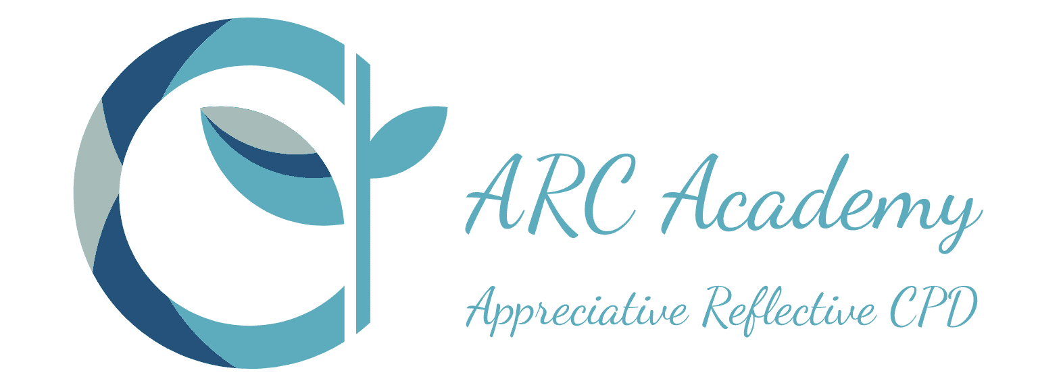

Through The Looking Glass: The Reflective Practitioner
a Study Day
Rewind events & Reflect on Practice. Explore the basics of reflective practice - key models and concepts.
Who is this course for?
- Speech & Language Therapists
- Assistant Practitioners in Speech & Language Therapy
- This introduction to reflective practice is relevant to other AHPs - OTs, Physios
- AHP Assistants e.g. OT and Physio

This workshop focuses on reflective practice rather than technical, clinical SLT skills and is relevant across healthcare professions.

What does it cover?
This course is designed as either:
- an introduction to the basics of reflective practice
- a reflective refresher course for those with prior learning

This course covers the basics of reflective practice and what makes a reflective practitioner. How critical reflection is a tool for learning and CPD.

Reflective practice is a key tool in learning and development. Writing reflectively is part of HCPC re-registration if called to audit and part of many master’s level courses. It is a consistent tool at all levels of learning.

Work based learning through reflective practice is integral to the new RCSLT Assistant Practitioner/Support Worker Framework.

Course Topics/Learning Themes
- Reflection in daily practice - imagery
- Reflective Practitioner on a Learning Journey
- The Extended Practitioner
- Expert in practice
- Decision making in ‘problem infested practice
- Looking through Lenses - 2D to 3D
- Rewind/Revisit/Reflect
- The Reflective Cycle
- Preview, In Action, Rewind
- Reflective Conversations
- Stories of Practice
- Creative approaches
- Reflection in Supervision

What will I achieve?
By the end of this course you should be able to:
- Know about the basic reflective learning cycle
- Knowing several different models of reflective practice (cyclical & linear)
- Know the history and development of reflective practice
- Relate to reflection on action, in action
- The concept of ‘knowing in action’
- Know about being a Reflective Practitioner
- Have confidence in Reflective Writing

How will I be taught, will there be any work outside the class?
Online via Teams with access to linked resources.

The format of the course involves presentation of the theory and practical application. There are opportunities for small group activities to network with colleagues, while exploring the topic and sharing ideas. The workshop ends with whole group working together to compile a ‘Take Aways from Today’ list.

Cost
£150
When and how long
See Course calendar for latest dates
Time: 9.30 to 16:00
Course Tutor
Ruth Howes
Author of Reflective Clinical Supervision in SLT: Strengthening your Supervision Skills (in production with Speechmark/Routledge due for publication Oct 22)

Booking
- You can book and pay instantly via PayPal
- You can ask for a quotation so your organisation can raise a purchase order
- You can ask us to send an invoice to yourself or your employer that can be paid by BACS
- Card Payment through Stripe will be available soon

